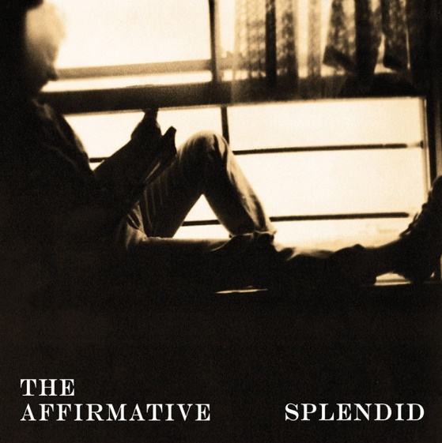

‘Splendid is exactly what it says on the sleeve!’

Claire Robinson, *Plymouth Herald*

Introducing

The

Affirmative

The Affirmative are an eclectic guitar driven rock band from Plymouth, fusing British indie with Americana, harnessing story-telling traditions from Bruce Springsteen to Ray Davis, to produce a Splendid debut album of songs ranging from the lyrically and musically complex, to quirky reminiscences about lost love and wasted summer days.

The Affirmative are a lapsed Londoner and a Belfast exile and their music is shaped by everything from the American South to the English South-West and many well-worn highways and byways between and beyond.

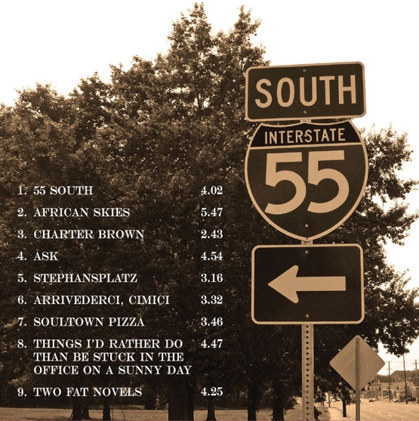

‘The King was twenty-five years gone when I first touched down in Memphis….’

Debut single 55 South available to download <https://theaffirmative.bandcamp.com/track/55-south>

The Affirmative:

Jon Shaw: Lead vocals; guitars; keyboards

Simon Topping: Bass; backing vocals

Email: [simon.topping@sky.com](mailto:simon.topping@sky.com)

Facebook: <https://www.facebook.com/theaffirmativesplendid/>

Phone: 07814538789

Find us on all majoring streaming services or order Splendid on CD now

Mixed and mastered by Ben Shepherd

Manufactured by Disc Manufacturing Services, Plymouth, Devon, UK

© 2017

